# **Assignment 2 - Documentation**

# **Introduction**

## About Spotify?

### Spotify Technology S.A. is a Swedish media-services provider founded in 2006. The company's primary business is its audio streaming platform that provides DRM-protected music and podcasts from record labels and media companies. As a freemium service, basic features are free with advertisements or automatic music videos, while additional features, such as improved streaming quality, are offered via paid subscriptions.

## Proof Of Concept

Spotify has recently launched a new product called FLAC (Free Lossless Audio Codec) audio streaming in the market. Spotify wants to improve the audio quality and understand the customer response to the newly launched product based on previous campaigns and promotions. Based on customer feedback on our newly launched product, analysts of Spotify will analyze the reviews and comments from different platforms and determine the sentiment of the customers from different states about the product, further expanding the market.

**EDA for our data:**

**State-wise leads to customer analysis:**

In the butterfly graph depicts the state-wise leads and leads to customer conversion metrics based on the campaigning months for various states. For the state of Texas, we can see that the lead to customer conversion rate is about 50% for the month of February and it varies from state to state.

**Insights**–

1. According to the results of this graph Marketing Managers and Marketing Analyst will get the information regarding the Campaign performance and leads to customer conversion statistics in each state. By this they can decide in which state the campaigns are performing good and can use that campaign for the promotion of the new product in that state.
2. Marketing managers can take necessary actions in campaign improvement for the state where leads to customer conversion is less.

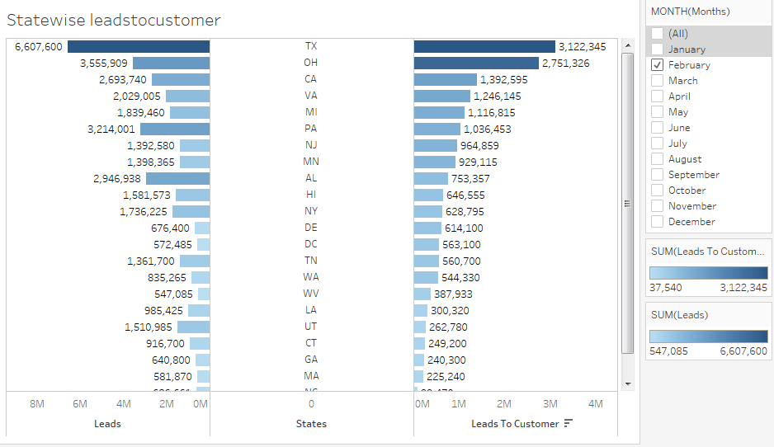

**Users Listening time based on state**

Each user listens to Spotify music at different times let it be morning, afternoon, evening, night. And one user might be using multiple music streaming companies to listen to music. So, based on the data that is in our hand we have analyzed that most of the users listen to music in the morning time regardless of the company and in that Tidal has the greatest number of listeners which are approximately 115M users for the state of CA during the morning time.

**Insights** –

1. This insight is for the Streaming technician of the Spotify, according to the state and the time (in which there are greatest number of listeners) Streaming technician can do fast and high quality streaming in that time.

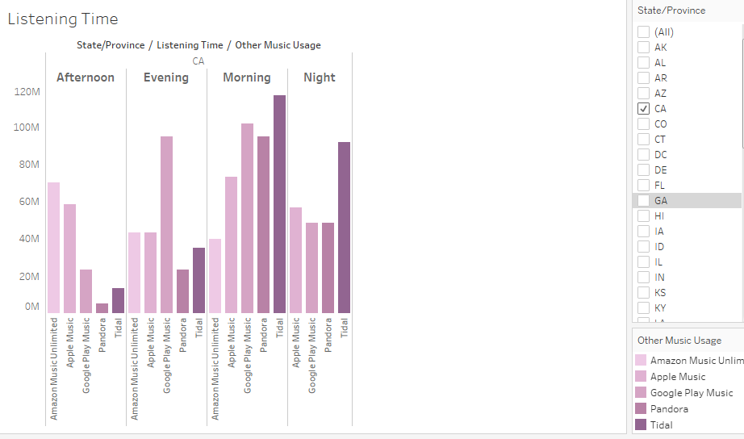

## Spotify Users Favorite Genre and age

Different users listen to different type of Genre and not all users listen to all genres. Based on the data, we plotted a histogram based on genre and the median age. We analyzed that ‘Country music’ genre has the most number of listeners and the median age of listeners is ‘55’ for the state of Florida. The next favorite genre for users is ‘Jazz’ and then ‘Blues’.

We can come to a conclusion based on this analysis to determine what kind of genres different age groups listen to.

**Insights** –

1. From the above analysis Marketing Decision Makers can decide to give promotions or concert tickets songs of the favorite Genre to the customers within that age range in the state.
2. Spotify IT team or the streaming technicians can provide the recommendations of songs of favorite genre to the customers of that age range.

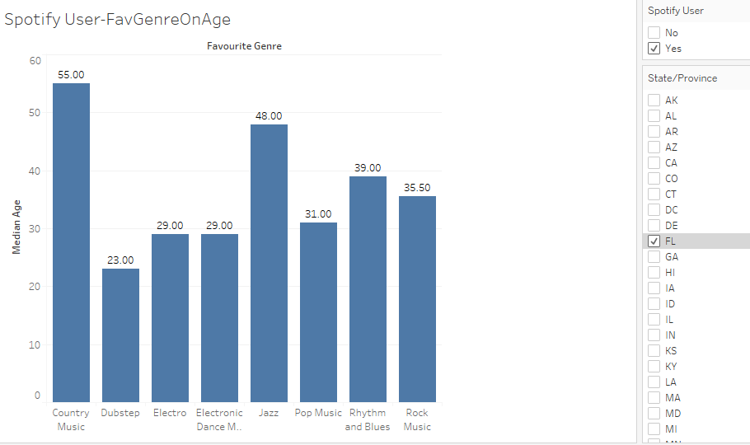

## Customer Satisfaction Based on State

Using the reviews of the customer which had mainly four categories being Highly Dissatisfied, Dissatisfied, Satisfied and Neutral we can determine the customer satisfaction for a particular state.

By performing this analysis on the donut chart below, we derive that in the state of MN, majority of the customers have given a ‘neutral’ review for customer satisfaction and the next highest is ‘highly dissatisfied’.

**Insights** – Marketing Managers and Marketing Budget Decision makers can give discounts or promotions to those customers with less satisfaction.

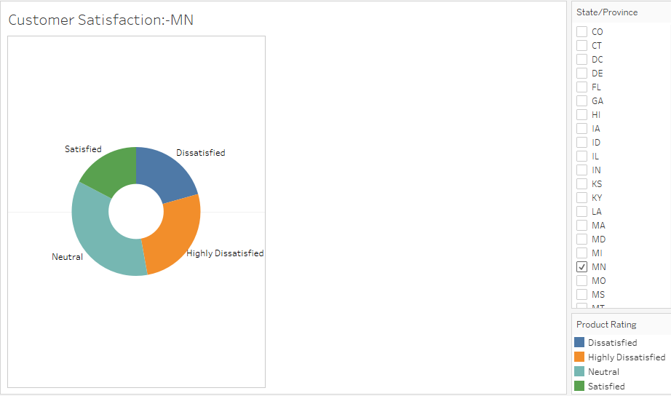

**Sentiment Analysis:**

Sentiment analysis seeks to quantify the emotional intensity of words and phrases within a text. We will be doing basic text processing methods such as tokenization, stop word removal, stemming and vectorizing text. Along with this we will determine the sentiment related to the review of the customer. We will use the Plot.ly library to make interactive graphs for sentiment analysis.

**Method 1** - We performed Sentiment Analysis using the NLTK-Natural Language Tool Kit libraries. Therefore, analyzed that the maximum number of customers have provided positive reviews.

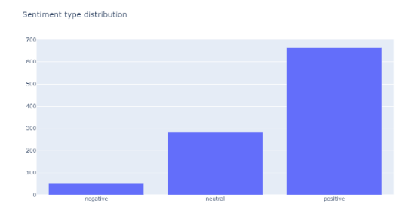

**Method 2** - We performed Sentiment Analysis using the NLP-Natural Language Processing to attain the sentiment analysis by AWS API.

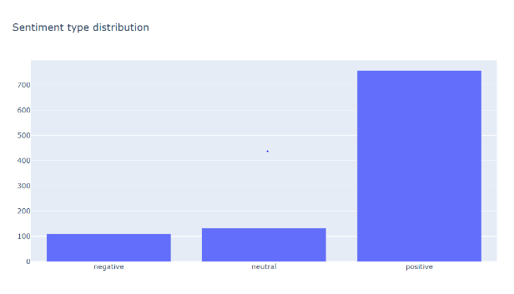

After analyzing and comparing with both the methods, we conclude that AWS API which uses comprehend NLP is more accurate when compared to NLTK method analysis.

**Market Sizing :**

There are various kinds of market sizing analysis: top-down, bottom-up, comparable, etc. We determine our market size using bottom-up analysis where we target our customers (number of opportunities and target customers) based on states, listening time, profit generated, the OS they use, and an yearly analysis of all of the above attributes.

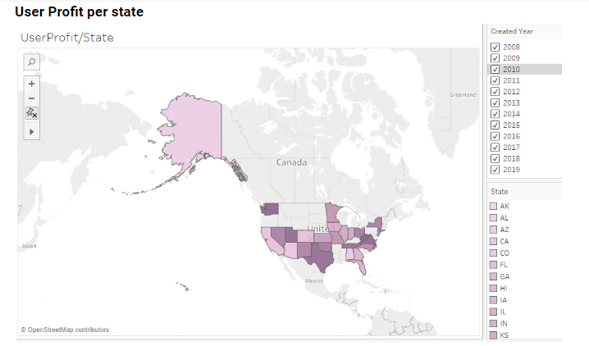

**W5H:**

**Who** -

Power users and Analysts, Marketing Managers and Marketing Analyst, Spotify Streaming technician, Marketing Budget Decision makers, Spotify IT team will be able to use this data to make decisions. Decisions like Campaigning budget, location, target audience, age groups, campaign types.

**What** -

* We analyzed the different campaign data for all our campaigns and determined which campaign has been successful in which state.
* Based on this analysis we can provide customers recommendation on the type of genres they listen to
* Focus can be provided to customers who are not much satisfied to increase their CLV
* Analysis on the performance of the new product based on the state and platform and to determine where it should be improved

**Why**

To determine the size of the market and the target audience for our newly launched product based on multiple parameters. Parameters like profits, location, age, genre. Also determine the break-even point for the new product has to be estimated.

**When**

When proposing a marketing strategy for new products you review your market research and sales performance of existing products in the company's range using recent sales figures to help identify the current level of market activity and interest in product in the same category as your new product

**Where**

Initially where the scope for the product market is existing and based on our previous products, campaigns and promotions, determining the focus points. Decisions like where to launch the product, to determine where the profit will be attained the most.

**How**

By performing the Exploratory data analytics on our datasets by gaining insights on our data and then by performing sentiment analysis on the reviews from the customers after our new product is released and finally based on these parameters determining the market size for our new product.

**Jupyter file link from Google CoLab:**

<https://colab.research.google.com/drive/1AhF9-e0-Qa4B-ZRMKqEI8rrUNWZEafMZ?userstoinvite=ankita27brahmankar%40gmail.com&actionButton=1>

**Tableau Public Dashboard links:**

[**https://prod-useast-a.online.tableau.com/#/site/ankitamoharir/workbooks/3485/views**](https://prod-useast-a.online.tableau.com/%23/site/ankitamoharir/workbooks/3485/views)

**CITATION:**

<https://outlier.ai/data-driven-daily/market-sizing/>

<https://outlier.ai/data-driven-daily/data-exploration/>

<https://outlier.ai/data-driven-daily/text-analysis/>

Tableau document - <https://onlinehelp.tableau.com/current/guides/get-started-tutorial/en-us/get-started-tutorial-share.htm>

Kaggle - <https://www.kaggle.com/arthurtok/spooky-nlp-and-topic-modelling-tutorial>